Muscular System – Notes

The muscular system is organised to maintain posture and produce movement; muscle fibre contraction can be explained using the sliding filament theory.
3 properties allow muscles to work together to create movement:
- Contractibility – The ability to contract.
- Extensibility – The ability to be stretched.
- Elasticity – The ability to return to the original length after being stretched.
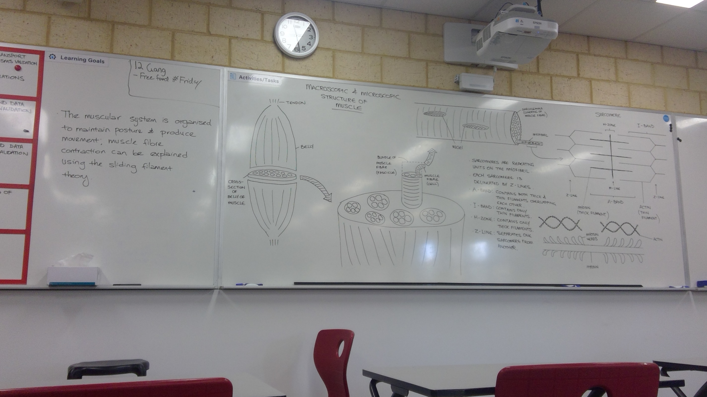
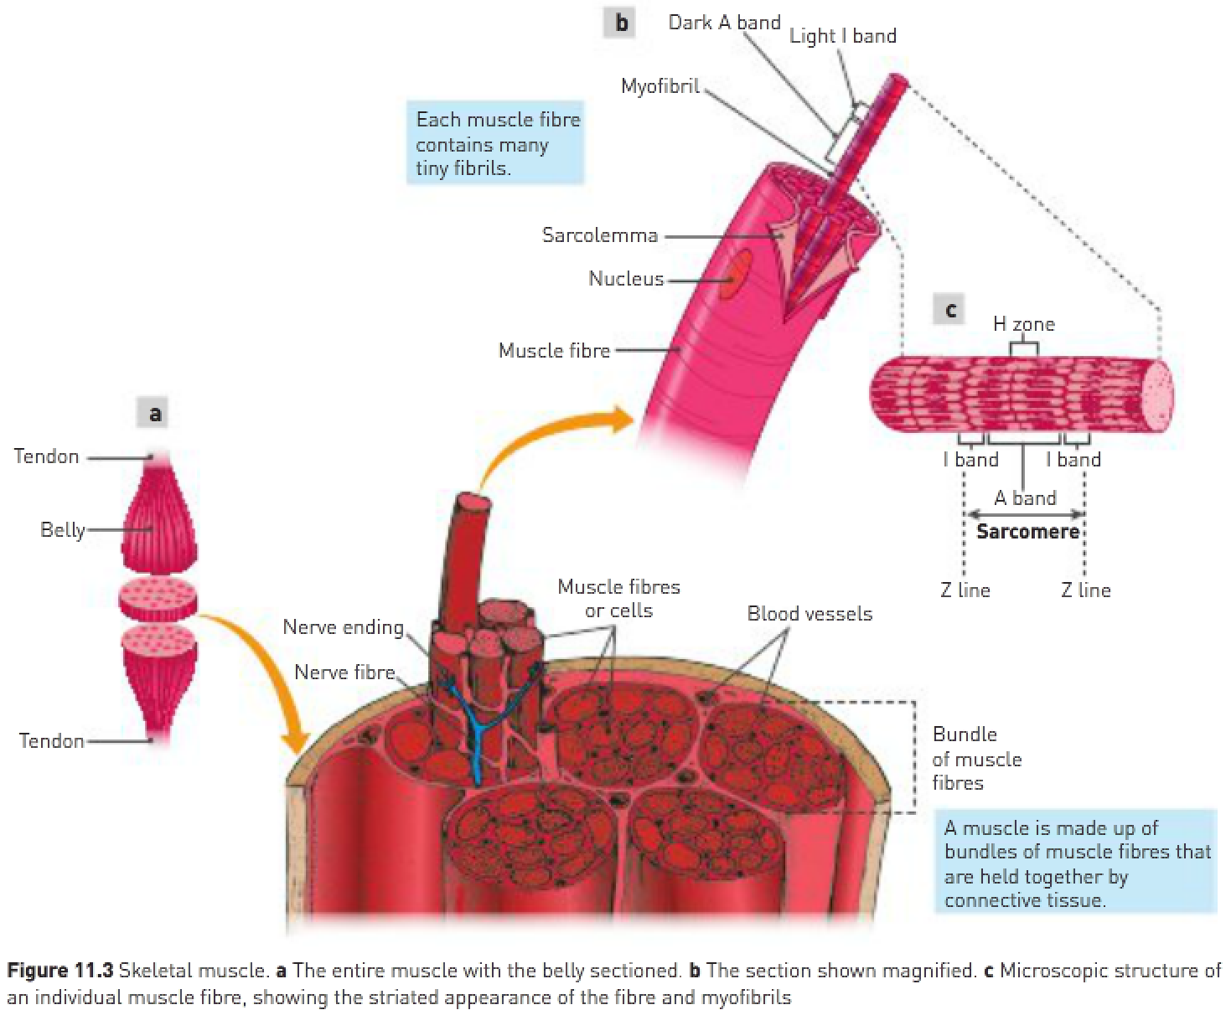
- The amount of connective tissue increases with advancing age.
- Each muscle cell is an elongated cylinder with many nuclei.
- Around the cell is a thin, transparent plasma membrane, called the sarcolemma, containing cytoplasm, called the sarcoplasm.
- These cylindrical cells are called muscle fibres.
- Within the sarcoplasm of each fibre there are thread-like myofibrils lying parallel to each other and running along the length of the fibre.

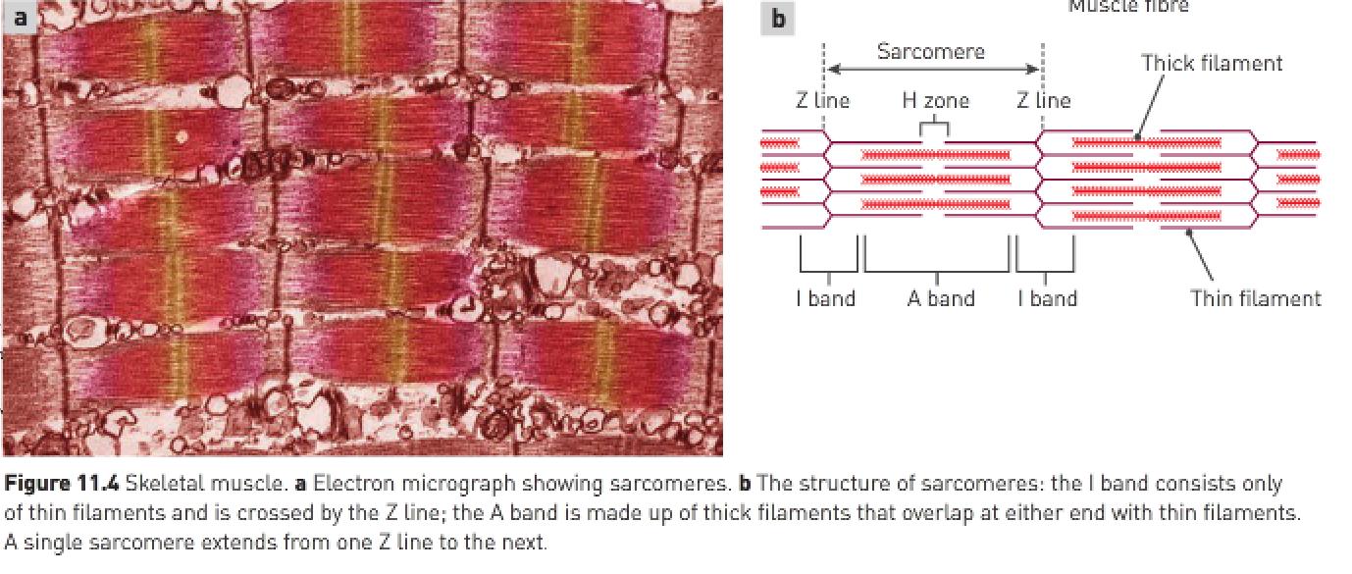
Structure of myofibrils:
- The myofibrils are composed of many smaller myofilaments made of protein, which are the units involved in contraction of muscle.
- There are 2 types of myofilaments:
1. Thin myofilaments (composed of the protein actin).
2. Thick myofilaments (composed of the protein myosin).
- When a muscle fibre is supplied with sufficient energy and is activated by a nerve impulse, these thick and thin protein filaments slide past each other in a manner that shortens the myofibril.
- Myofibrils can be divided into units called sarcomeres.
- The striated appearance of skeletal muscle is due to variations in the actin and myosin content in different parts of the sarcomere.

Sliding filament theory:
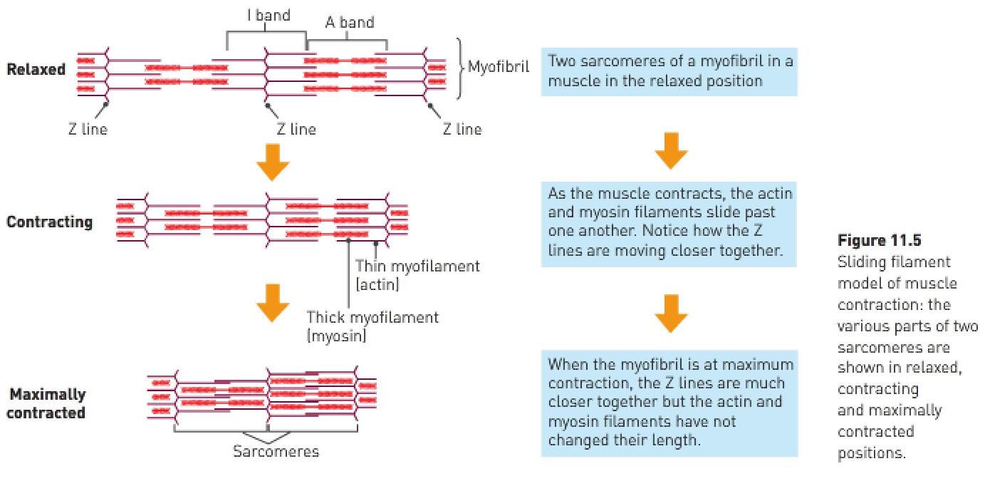
- As the thin actin filaments slide over the thick myosin filaments, the Z lines are drawn closer together and the sarcomere is shortened.
- The fibril has shortened because the myofilaments overlap more.
- The energy required for shortening of the muscle fibres comes from the breakdown of ATP in the muscle cells.
- Energy is released when ATP breaks down to ADP+P.

Sliding filament theory:
- A nerve impulse reaches the bundle of muscle fibres and triggers the release of calcium from the sarcoplasmic reticulum.
- The calcium binds to the actin myofilaments and this causes the myosin binding sites to be exposed to the myosin.
- The myosin myofilament joins to the myosin binding sites on the actin and forms crossbridges.
- The formation of crossbridges requires energy (ATP).
- The myosin crossbridges pull on the actin and the actin slides over the myosin (note: myosin doesn’t change in length). This also requires ATP and is the muscle-shortening phase of muscular contraction. This is called downstroke.
- Z-lines move close together / sarcomere shortens.
- It requires ATP to cause the myosin to “unhook” off the binding sites. Once the crossbridges move off the binding sites, the actin slides back to the “resting” position. Z-lines move further apart / sarcomere lengthens.

- Muscles are attached to the bones of the skeleton by fibrous, inelastic connective tissue called tendons.
- Coordination of the paired muscles provides body movement, with one air producing movement of bones in one direction and the other producing movement in the opposite direction – such pairs are referred to as antagonists.
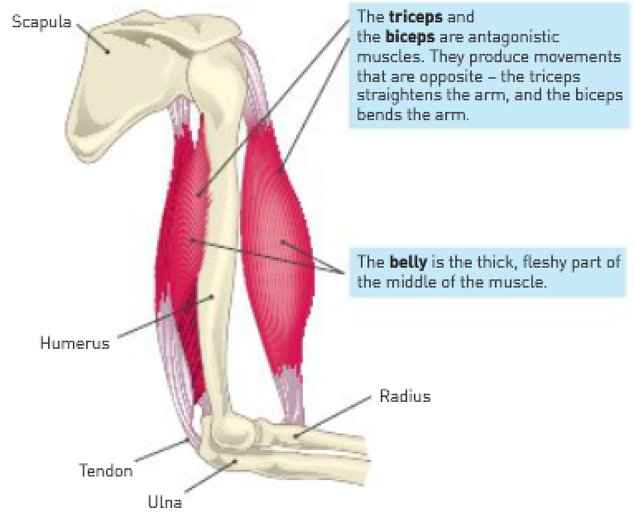
Origin: The end of the muscle fixed to the stationary bone.
Insertion: The attachment of the other end of the muscle, to the moveable bone.
Belly: The fleshy portion of the muscle between the tendons of the origin and the insertion.
Agonist (prime mover): A muscle that causes a desired action.
Antagonist: A muscle that has the opposite effect of the desired action.
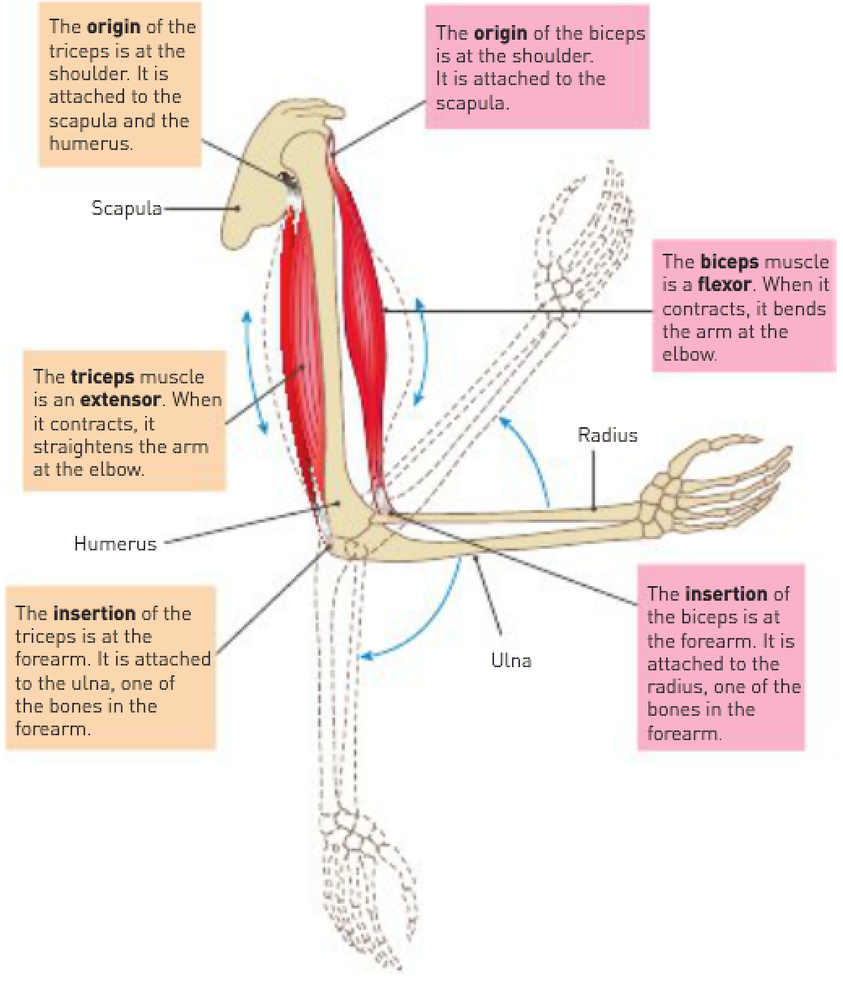
Synergists: Muscles that help the prime mover.
Fixator: A synergist that immobilises a joint to prevent unwanted movement.
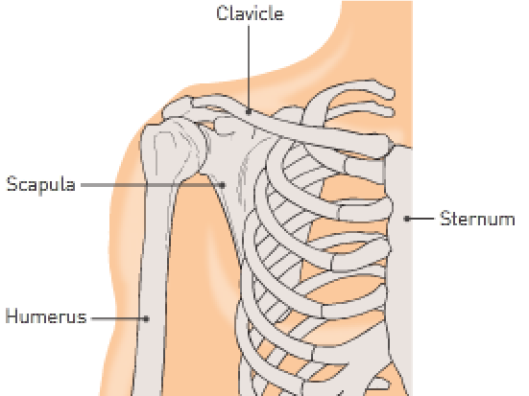

Synergists:
- May produce the same movement as the prime mover or they may steady a joint during a particular movement so that unwanted movement is prevented.

- The same muscle may at different times be an agonist, antagonist or synergist.

Muscle tone:
- Maintaining partial contraction of skeletal muscles.
- At any one time, some muscle fibres are contracted while others are relaxed.
- Not caused by the constant contraction of the same fibres, but by many different fibres taking turns to contract.

Posture: The characteristic way a person holds their body when standing or sitting.

